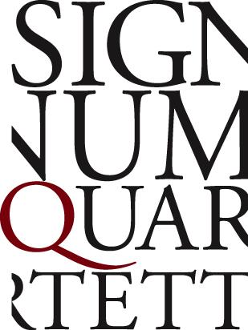

Florian Donderer, violin
Annette Walther, violin
Xandi van Dijk, viola
Thomas Schmitz, cello

Unsparing expressivity, intimacy and vitality are hallmarks of the Signum Quartet’s performances, combining music-making of the utmost subtlety with playing of exceptional intensity. Their programmes are distinguished by innovative and distinctive dramaturgies, realised through interpretations of remarkable clarity and precision. (“enormously intelligent and knowledgeable programming” — Rondo Magazin)

The quartet is a welcome guest at Carnegie Hall in New York, Wigmore Hall in London, the Berlin Philharmonie, Concertgebouw Amsterdam, Philharmonie de Paris, the Konzerthaus Vienna, Philharmonie Cologne, the Elbphilharmonie Hamburg and the BBC Proms, performing with partners such as Jörg Widmann, Nicolas Altstaedt, Nils Mönkemeyer, Dominique Horwitz, Daniel Ottensamer and Elisabeth Leonskaja.

The Signum Quartet’s discography is a testament to their stylistic range: alongside the greats of the quartet literature, they have recorded works by Wolfgang Rihm, Thomas Adès, Jörg Widmann, Kevin Volans and Erkki-Sven Tüür. Their recording of Tüür’s Second String Quartet Lost Prayers for ECM won Classical Album of the Year at the Estonian Music Awards 2021, followed by “a dark flaring”, an album devoted to South African compositions from the 20th and 21st centuries, which received the prestigious Italian critics’ award Premio Abbiati del Disco in 2026.

Their Schubert trilogy for PENTATONE began in 2018 with the multi-award-winning “Aus der Ferne” (Diapason D’Or, OPUS Klassik), followed in 2020 by “Ins stille Land”, which deepened their exploration of the connections between Schubert’s string quartets and songs (“The Signum’s ‘Death and the Maiden’ is up there with the best from a crowded field”—The Strad). In 2023, “Lebensmuth” completed the trilogy, continuing this dialogue between Schubert’s quartets and songs, and won the OPUS Klassik 2024 for Best Chamber Music Album of the Year. Most recently, the quartet released “the earth trembled”, recontextualising the visionary string quartets of Leoš Janáček alongside Vítězslava Kaprálová’s striking String Quartet Op. 8 (“the entire programme is as illuminating as it is riveting.” —Gramophone).

In 2015, the quartet launched its innovative social media project #quartweet, where composers of all ages and abilities were invited to tweet a short quartet of 140 notes or less on Twitter. The project received much media attention and was featured on Deutschlandfunk, BBC In Tune and BR U-21. Contributing composers included Caroline Shaw, Brett Dean, Bruno Mantovani and Sebastian Currier.

In 2024, the Signum Quartet launched their “Bridge the chasms that divide” project, commemorating 30 years since the fall of apartheid in South Africa. For this, they invited some of South Africa‘s most original and powerful voices to reflect on their own experiences and journeys before and after 1994, including composers such as Abel Selaocoe and Dizu Plaatjies. The project featured premieres at the Kölner Philharmonie and Berlin’s Pierre Boulez Saal, with an album of the commissioned works forthcoming.

On Bremen’s Überseeinsel, the Signum Quartet has created SIGNUM open space, their home for artistic work, exchange and collaboration. Supported by the Senator for Culture of Bremen from 2024–2026, the centre is based on the former Kellogg’s factory site and brings together rehearsals, concerts, workshops and interdisciplinary projects. Artists and ensembles from Bremen and around the world meet here, with chamber music and music education at its heart.

The Signum Quartet performs on the “Pearl” quartet, a matched set of instruments crafted by the renowned German luthier Stefan-Peter Greiner.

