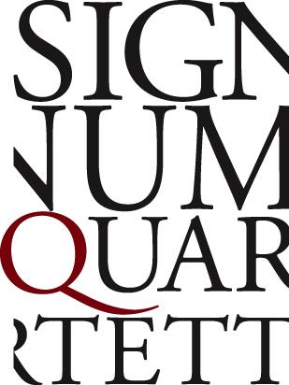

...one of the most sensitive interpretations ever recorded.
Diapason, Schubert “Aus der Ferne”

Performances of unsparing expressivity, intimacy and vitality are hallmarks of the Signum Quartet, pairing music making of the subtlest order with playing of the highest intensity. The dramatic composition of their programmes is innovative and distinct, and is realised with uncompromising perfection in interpretations of effortless transparency. (“enormously intelligent and knowledgeable programming”—Rondo Magazin)

The quartet has been a welcome guest at the Wigmore Hall London, Concertgebouw Amsterdam, Philharmonie de Paris, Konzerthaus Vienna, Philharmonie Cologne, the Elbphilharmonie Hamburg and at the BBC Proms, with partners such as Nils Mönkemeyer, Dominique Horwitz, Jörg Widmann, Daniel Ottensamer, Nicolas Altstaedt and Elisabeth Leonskaja. In 2023 the ensemble will give its debut at Carnegie Hall in New York.

The Signum Quartet’s discography is a testament to their stylistic range: Next to the greats of the quartet literature, they have recorded works by Wolfgang Rihm, Thomas Adès, Jörg Widmann and Kevin Volans. Their recording of Erkki-Sven Tüür’s Second String Quartet Lost Prayers for ECM won Classical Album of the Year at the Estonian Music Awards 2021.

Following their multi-award-winning album “Aus der Ferne” (Diapason D’Or, Opus Klassik), the Signum Quartet continued its Schubert cycle for PENTATONE with “Ins stille Land”, deepening its exploration of the fascinating connections between his string quartets and songs. (“The Signum’s ‘Death and the Maiden’ is up there with the best from a crowded field”—The Strad)

In 2015, the quartet launched its innovative social media project #quartweet, where composers of all ages and abilities are invited to tweet a short quartet of 140 notes or less on Twitter. The project has received much media attention and been featured on Deutschlandfunk, BBC In Tune and BR U-21. Contributing composers include Bruno Mantovani, Grawemeyer Award winners Brett Dean and Sebastian Currier and Pulitzer Prize winner Caroline Shaw.

In 2022 the quartet established its Bremen-based project SIGNUM open space, supported by Neustart Kultur. This will be a site for rehearsals, recordings, workshops and education initiatives as well as an interactive exchange with the public. Additionally, there will be interdisciplinary projects such as exhibitions, readings, dance and seminars with renowned lecturers.

